# LAB # 10

**Objective: Determine of wavelength, time period, and frequency of a given AC signal by oscilloscope.**

**Equipment:**

* + Oscilloscope
  + Signal generator (if required for generating the AC signal)
  + Probe (for connecting the signal to the oscilloscope)
  + Cables and connectors

**Theory:**

**AC Signal Characteristics**

An alternating current (AC) signal periodically varies in magnitude and direction. It can be described by its fundamental properties: frequency, time period, and wavelength.

* + **Frequency (f)**: The number of cycles that occur in one second, measured in Hertz (Hz). It is the reciprocal of the time period.

**f = 1/T**

* + **Time Period (T)**: The time it takes to complete one full cycle of the waveform, measured in seconds

(s). It is the inverse of frequency (**T = 1/f**)

**T=Number of divisions × Time per division**

* + **Wavelength (λ)**: The distance between successive peaks (or troughs) of the waveform. It is related to the speed of propagation of the signal and its frequency.

**λ = v / f**

where: v is the speed of the signal in the medium (e.g., speed of light in vacuum c≈3×108 m/s) f is the frequency in Hertz (Hz).

**Procedure:**

1. **Setup**

**Connect the Oscilloscope:**

* + Connect the oscilloscope probe to the input channel of the oscilloscope.
  + Connect the other end of the probe to the signal source (AC signal). Ensure proper grounding to avoid noise and interference.

**Configure the Oscilloscope:**

* + Turn on the oscilloscope.
  + Adjust the vertical scale (volts per division) and horizontal scale (time per division) to properly display the waveform.

1. **Display the Waveform Triggering:**
   * Set the oscilloscope to trigger the AC signal. This will stabilize the waveform on the screen for accurate measurements.

**Adjust Controls:**

* + Fine-tune the vertical and horizontal controls to view one or more complete cycles of the waveform.

1. **Measure the Time Period**

**Identify the Peaks or Zero Crossings:**

* + Measure the horizontal distance between two successive peaks or zero crossings of the waveform. This distance represents the time period T.

**Use the Time Base:**

* + The oscilloscope’s time base (time per division) and the number of divisions between two peaks (or zero crossings) can be used to calculate the time period:

**T = Number of divisions × Time per division**

1. **Calculate the Frequency Using the Time Period:**
   * The frequency f can be calculated using the formula: **f = 1/T**

Where T is the time period measured in seconds.

1. **Determine the Wavelength Calculate Wavelength:**
   * The wavelength λ is given by: **λ=v/f**

Where v is the speed of the signal in the medium (for electrical signals in air or cables, this is often the speed of light c or the speed in the cable).

**Observation:**

|  |  |  |
| --- | --- | --- |
| **Measurement** | **Value** | **Unit** |
| **Time Period (T)** |  |  |
| **Frequency (f)** |  |  |
| **Wavelength (λ)** |  |  |
| **Time per Division** |  |  |
| **Number of Divisions** |  |  |
| **Signal Speed (v)** |  |  |

**Conclusion:**

In this lab, we utilized an oscilloscope to measure the time period, frequency, and wavelength of an AC signal.

**Safety precautions:**

* + Check all equipment, including the oscilloscope and signal source, for proper working conditions before starting the experiment.
  + Ensure all connections are secure and properly insulated to prevent short circuits or electric shocks.
  + Do not exceed the maximum voltage rating of the oscilloscope or probes.
  + Use probes rated for the voltage and frequency of the signal being measured.
  + Avoid touching probe tips or exposed wires while the equipment is powered on.
  + Ensure the oscilloscope probe’s ground clip is properly connected to a common ground point.

**Waveform:**

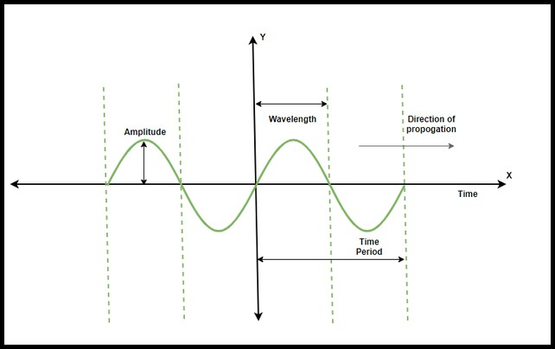

**POST LAB:**

1. How do you measure the time period of a sine wave using an oscilloscope?
2. What is the formula to calculate the frequency of a signal from its time period?
3. How can you determine the wavelength of a signal if you know its frequency and the speed of propagat ion?
4. What setting on the oscilloscope allows you to measure the frequency of a signal directly?